📊 EURGBP (H1) — Decision
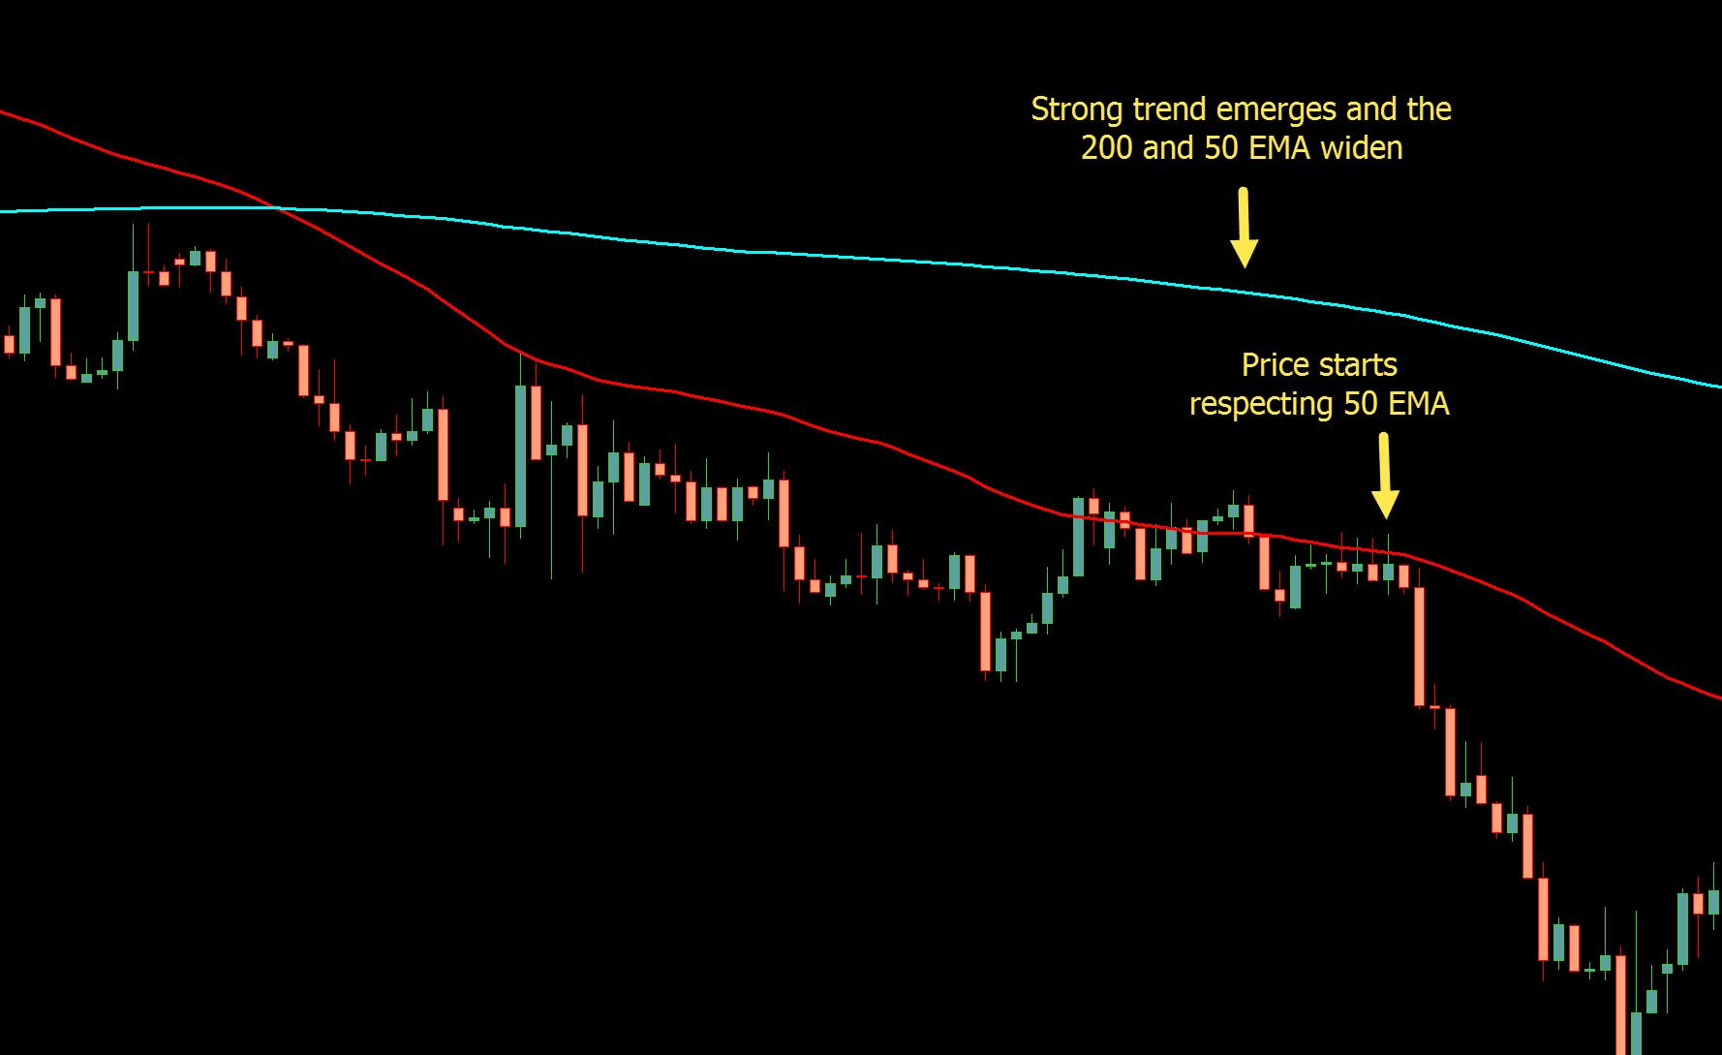
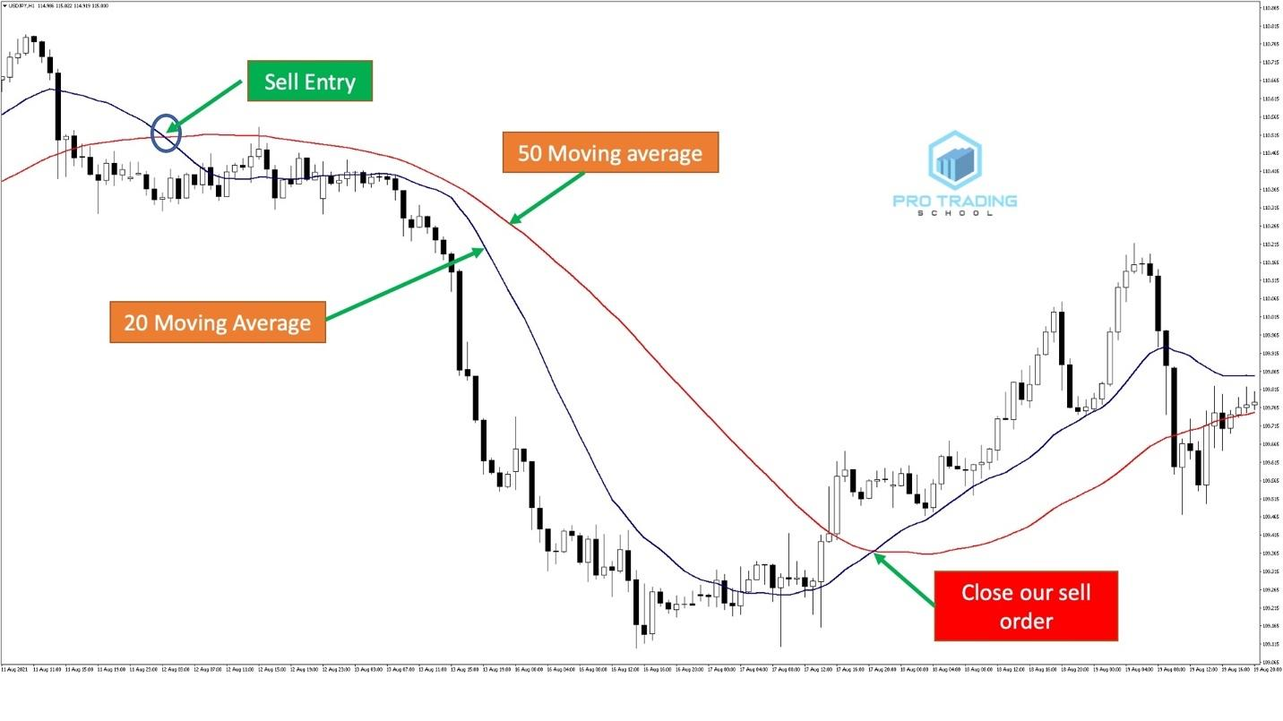
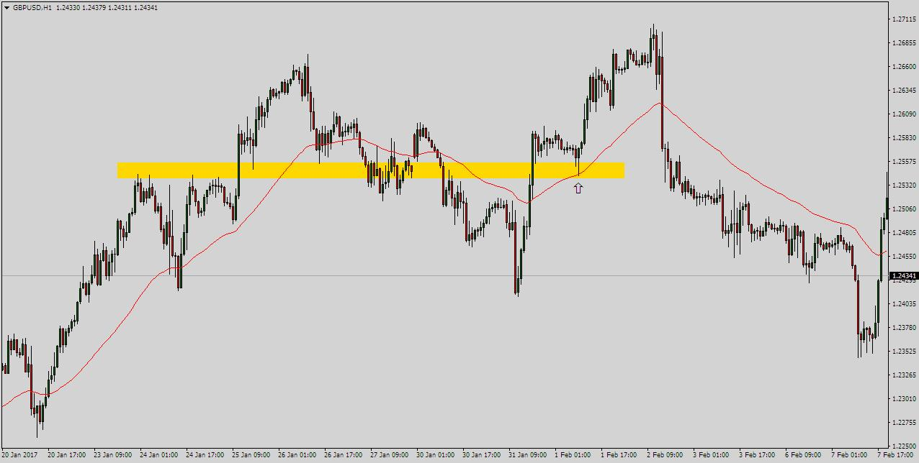
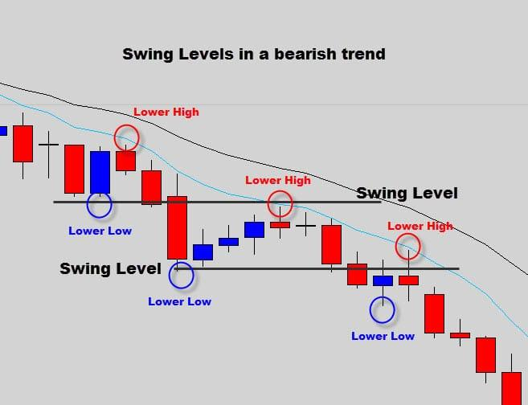
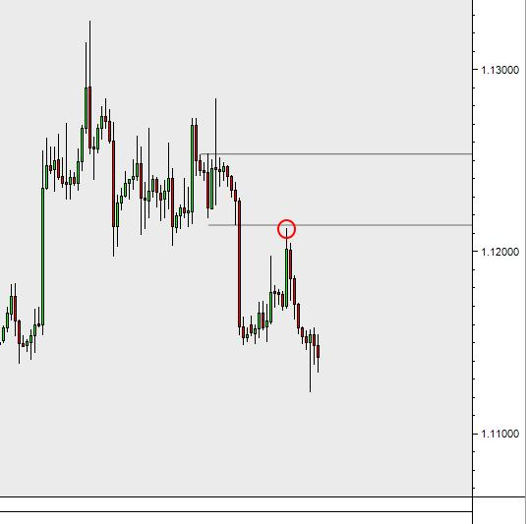
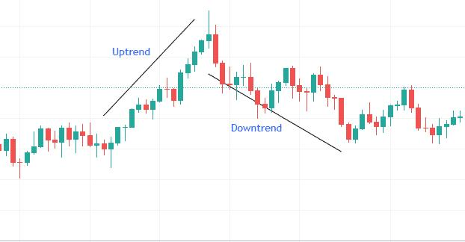

🔍 What I’m Seeing
- Clear downtrend structure (lower highs, lower lows)
- Price is below EMA 200 (blue) → long-term bearish
- EMA 50 (red) is below EMA 200 → confirmed trend
- Price keeps rejecting around EMA 50 → selling pressure
👉 This is a SELL market

⚠️ But Timing Matters
Right now:
- Price is not at a perfect entry
- Market is slightly choppy after a move
👉 Don’t just sell anywhere.

🎯 Best Trade Plan

🥇 Option 1: Pullback Sell (BEST)
Wait for price to:
- Move up toward EMA 50 (red)
- Show rejection (small candles → bearish candle)
👉 Then SELL

🥈 Option 2: Breakout Sell
- If price breaks recent low
- Enter on retest
👉 Then SELL

❌ Avoid
- Selling at the very bottom of a big drop
- Entering when price is far from EMA

🧠 EA Perspective
Your bot should:
- Prefer SELL trades only
- Ignore BUY unless structure flips

🔥 Final Answer
👉 Direction: SELL
👉 Action: WAIT for pullback or clean breakout

If you want next:
I can tune your EA so it only sells when price pulls back to EMA 50 + confirmation candle (this will reduce bad entries a lot).

